React Native Architecture — Complete Guide
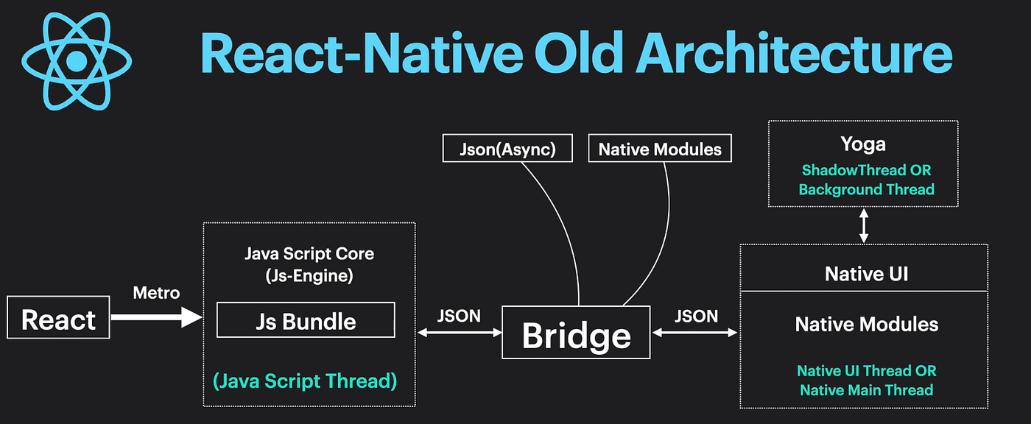

React Native new Architecture:
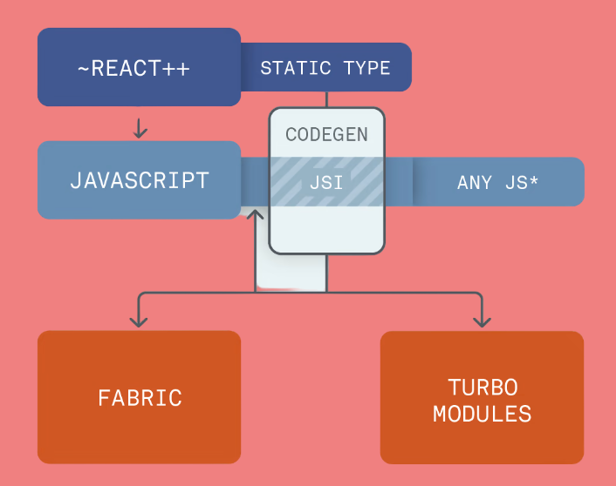
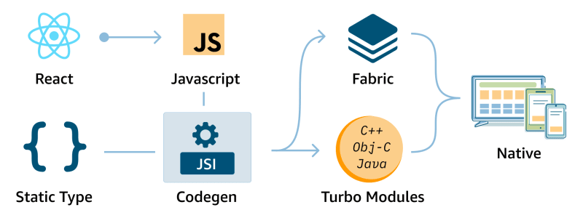
React Native architecture explains how JavaScript code talks to native Android/iOS components to render real mobile UI.
Let’s break it down clearly.

Core Idea
React Native apps are written in JavaScript/TypeScript, but UI components are native, not web views.
Flow:
React Native JS Code
↓
Bridge / JSI Layer
↓
Native Modules & UI
↓
Android / iOS Platform
So your app:
- Runs JS logic
- Uses native UI components
- Communicates via an internal bridge mechanism

Main Architecture Components
1) JavaScript Thread
Runs:
- React components
- Business logic
- State management
- API calls
- Navigation logic
Everything written by developers runs here.

2) Native Side (Platform Layer)
Actual mobile components:
- Android Views
- iOS UIKit components
- Camera
- GPS
- Storage
- Sensors
React Native maps components to native UI:
<View> → Android View / iOS UIView
<Text> → Native text component

3) Bridge (Old Architecture)
The bridge connects JS and native code.
Process:
JS Thread
↓
Serialize message
↓
Bridge queue
↓
Native execution
Problem:
- Async communication
- Serialization overhead
- Performance bottlenecks in heavy apps

New React Native Architecture (Modern)
React Native introduced a new architecture to fix bridge issues.
Components:
1) JSI (JavaScript Interface)
JS can call native code directly without bridge serialization.
Result:
- Faster communication
- Lower latency

2) TurboModules
Improved native modules:
- Lazy loaded
- Faster access
- Direct JS communication

3) Fabric Renderer
New UI rendering system:
- Faster UI updates
- Concurrent rendering
- Better animation performance

Architecture Layers Overview
App Code (JS/TS)
↓
React Native Framework
↓
JSI / TurboModules / Fabric
↓
Native Modules & UI
↓
Android / iOS OS

Threads Used in React Native
JavaScript Thread
Runs React logic.
UI Thread (Main Thread)
Handles:
- Rendering
- Touch events
- UI updates
Shadow Thread
Calculates layout using Yoga engine.

Rendering Flow
JS renders components
↓
Layout calculated
↓
Instructions sent to native
↓
Native renders UI

Performance Bottlenecks (Old Architecture)
Problems occurred when:
- Too many bridge calls
- Large JSON messages
- Heavy animations
- Large lists
New architecture solves most of these.

Enterprise-Grade App Architecture
Production React Native apps usually structure like:
src/
├── app/
├── components/
├── screens/
├── navigation/
├── services/
├── store/
├── hooks/
├── utils/
├── theme/
└── assets/

Recommended Stack (2026)
Modern RN apps use:
- React Native (latest)
- Expo or CLI
- TypeScript
- React Navigation
- Zustand / Redux Toolkit
- React Query
- NativeWind / Styled Components

Old vs New Architecture
Feature | Old Bridge | New Architecture
Communication | Async bridge | Direct calls
Performance | Slower | Faster
UI Rendering | Legacy | Fabric
Modules | Native Modules | TurboModules
Scalability | Limited | High

Key Takeaway
React Native works by:
JavaScript Logic + Native UI + Efficient Communication Layer
New architecture makes RN suitable for large-scale enterprise apps.

